|  |  |
| --- | --- |
| Christiaan Gerhardus Viljoen | Dr Thomas Dietel |
| **STUDENT NUMBER: VLJCHR004** | **SUPERVISOR** |
| [christiaan.viljoen@cern.ch](mailto:christiaan.viljoen@cern.ch) | [thomas.dietel@cern.ch](mailto:thomas.dietel@cern.ch) |
| Department of Statistical Sciences | Department of Physics |
| PD Hahn Building | RW James Building |
| University Avenue North | University Avenue |
| University of Cape Town | University of Cape Town |
| Rondebosch, Cape Town, South Africa | Rondebosch, Cape Town, South Africa |

# Masters Dissertation

## PHY5008W

**The Application of Machine Learning Techniques towards the Optimization of High Energy Physics Event Simulations in the at**

† A Large Ion Collider Experiment

‡ European Organization for Nuclear Research/ Organisation Européenne  
pour la Recherche Nucléaire

͛ Transition Radiation Detector

# Submitted in Fulfilment of the Degree: MSc Data Science



Contents

Christiaan Gerhardus Viljoen 1

Dr Thomas Dietel 1

Masters Dissertation 1

PHY5008W 1

Submitted in Fulfilment of the Degree: MSc Data Science 1

Background 3

A Large Ion Collider Experiment (ALICE) 3

Introduction to Experiment 3

The ALICE Transition Radiation Detector (TRD) 3

Motivation 5

Research Question 5

Aims & Objectives 5

Methods 5

Bibliography 5

# Background

## A Large Ion Collider Experiment (ALICE)

### Introduction to Experiment

A Large Ion Collider Experiment (ALICE) is a large scale collaborative experiment dedicated to studying all collisions involving heavy ions at the Large Hadron Collider (LHC) at CERN (European Organization for Nuclear Research) (1).

In central high energy collisions between heavy ions (i.e. where the centres of colliding nuclei overlap sufficiently), a newly discovered deconfined state of strongly interacting matter, the Quark Gluon Plasma (QGP) can be created in small amounts (1). It is thought that this state of matter was dominant during the first 10-6 s of the Universe’s existence (2). Studying the QGP allows us to explore fundamental research avenues such as Cosmology, the Evolution of our Universe, and one of the fundamental forces in the standard model that is the hardest to probe: the strong nuclear force (2).

ALICE is the first experiment in history capable of producing the QGP in a laboratory setting; and as such, it is equipped to infer a variety of physical variables relating to the QGP, by analysing data from electrons produced during many of the physical processes that occur in the wake of heavy ion collisions, e.g. open heavy-flavour hadron decays, virtual photons, etc (1). Robust electron identification is therefore a crucial part of studying the QGP, and accurately-tuned detector triggers ensure the collection of sufficient amounts of data to guide inferences regarding the statistical distributions of the abovementioned measurables (1).

### The ALICE Transition Radiation Detector (TRD)

#### Introduction

The main purpose of the ALICE Transition Radiation Detector (TRD) is the identification of electrons, as well as the operation of event triggers that determine whether data from a specific collision should be kept, based on measurements such as collision centrality, amongst others. As an added benefit, the TRD informs the ALICE central barrel’s calibration, and the data it produces is used extensively during track reconstruction (1).

#### TRD Physical Properties

The TRD is located within the ALICE central barrel, it’s inner boundary sits at a radial distance of 2.90 m from the beam axis. It contains 522 chambers, each of which contains a fiber/ foam radiator, a 3 cm drift region and a multi-wire proportional chamber (MWPC) filled with Xenon-; these chambers are arranged in a six-layer configuration (1). The position of the TRD within the ALICE central barrel is shown in ***Figure 1***.

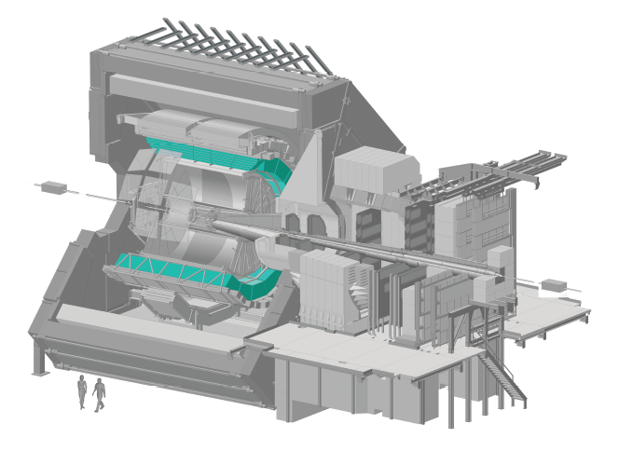

Figure 1: The ALICE TRD, Highlighted in Cyan, within the ALICE main detector (3)

#### TRD Measurement Mechanism

As the name suggests, transition radiation occurs when a particle transits across a dielectric boundary, this radiation is often measured in particle detectors to inform track reconstruction. Multiple boundaries are typically required to increase radiation yield, and since highly relativistic particles emit transition radiation that extends into the X-ray domain, the TRD utilizes gases with high proton-number (Z) to absorb this radiation, resulting in a high yield of energy deposition relative to the energy lost via ionization (1).

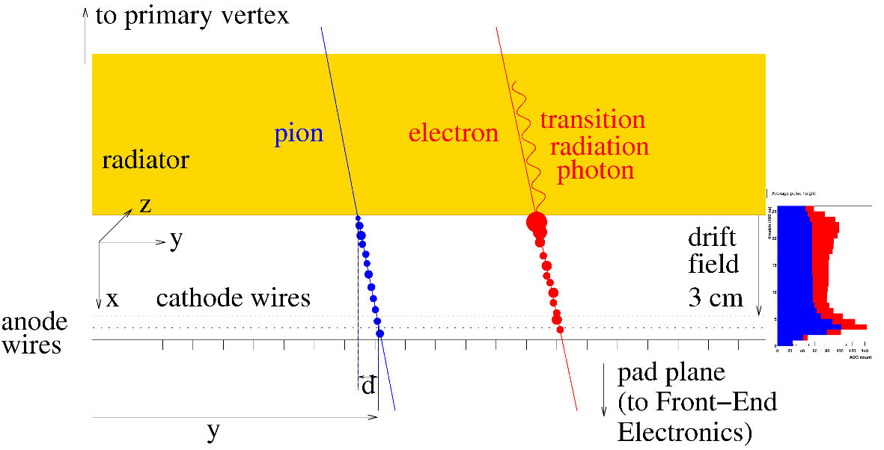

Figure 2: A schematic representation of the components in an MWPC Module

The drift time of gas particles within the MWPC provides fine-grained positional information about where the particle tracklet passed through the radiator. The detected signal takes the form of charged gas molecules, ionized via interaction with transition radiation photons and amplified through a chain of interactions between gas molecules, finally being absorbed by a negatively charged wire (anode) (3), this process is depicted in ***Figure 2***.

#### Identifying Electrons

The production of Transition Radiation, as well as a higher specific ionization energy loss , are two features that enable accurate differentiation of electrons from other charged particles; and the temporal data provided by the TRD further enhances the specificity and sensitivity of the electron identification process.

#### Current TRD Accuracy

Currently, at a momentum of around 1 GeV/*c*, a pion rejection factor of 410 is achievable in p-Pb (proton-Lead) collisions, with resolution improving by about 40% when TRD data is included in track reconstruction (1).

# Motivation

# Research Question

# Aims & Objectives

# Methods

# Bibliography

1. *The ALICE Transition Radiation Detector: Construction, operation and performance.* **Collaboration, ALICE.** 2018, Nuclear Inst. and Methods in Physics Research, Vol. 881, pp. 88-127.

2. **Reed, Rosi.** What is the QGP? *Quantum Diaries.* [Online] [Cited: 3 October 2018.] https://www.quantumdiaries.org/2011/11/23/what-is-the-qgp/.

3. **More details on the ALICE TRD. *ALICE - CERN.* [Online] CERN. [Cited: 3 October 2018.] http://alice.web.cern.ch/detectors/more-details-alice-trd.**